

Hamdard University

Department of Computer Science (FEST)

***Final Year Project  
2nd Evaluation Report***

Services Management System for Housing Society

Muhammad Areeb Vohra / BSCS-F14-0112

Muhammad Taha Amin / BSCS-F14-0117

Abdul Moiz Hussain / BSCS-F14-0128

**Supervision from:**

Sir Adnan Ahmed Siddiqui

*(Assistant Professor)*

Table of Contents

[1.0 Introduction 3](#_Toc501665400)

[1.1 Problem Statement 3](#_Toc501665401)

[1.2 Motivation 3](#_Toc501665402)

[1.3 Aims & Objectives 3](#_Toc501665403)

[1.4 Literature Review 3](#_Toc501665404)

[2.0 Project Scope 4](#_Toc501665405)

[2.1 Requirements 5](#_Toc501665406)

[3.0 Methodology 6](#_Toc501665407)

[3.1 Project Approach 6](#_Toc501665408)

[3.2 Team Role & Responsibilities (RACI Matrix) 6](#_Toc501665409)

[3.3 Design 7](#_Toc501665410)

[3.4 Development 8](#_Toc501665411)

[4.0 Project Planning 9](#_Toc501665412)

[4.1 Gantt Chart 9](#_Toc501665413)

[4.2 Timeline & Current Status 9](#_Toc501665414)

[4.3 Evidences of Progress 10](#_Toc501665415)

[4.4 Milestones 11](#_Toc501665416)

[5.0 Project Requirements 17](#_Toc501665417)

[5.1 Software Tools Requirements 17](#_Toc501665418)

[5.2 Hardware Requirements 17](#_Toc501665419)

[6.0 Budget 17](#_Toc501665420)

[6.1 Budgeting Cost of Each Item 17](#_Toc501665421)

[6.2 Total Budgeted Cost 17](#_Toc501665422)

[7.0 Project Deliverables 18](#_Toc501665423)

[8.0 References 18](#_Toc501665424)

# 

# 1.0 Introduction

## 1.1 Problem Statement

In housing societies, problems regarding any household issues like electricity, plumbing, gas leakage, carpentry, fumigation, etc. the person himself has to go and bring the repair man, which takes a lot of time and effort.

## 1.2 Motivation

The proposed project introduces the application which will integrate society’s every problem on a platform, and the problem will be on few clicks away to be solved.

## 1.3 Aims & Objectives

* The main objective of this project is to develop a web and application based software that is used to inform about the problem of the person is having, concerning any household problems like leakage of gas, water seepage, electricity issues, plumber required for wrecked furniture etc.
* As Android based smart phones have become very popular and common devices for innovations, so we are using this platform as a user interfacing medium.
* The salient objective to develop a mobile application is for the reduction of complexity in the system and essentially to save people’s time.
* And definitely a web based service control manager where all the required services of the users will be entertained and responded.

## 1.4 Literature Review

Study of Implementation of Society Management System

The concept of this paper is that to keep the people of a society up to date with their daily activities, by notifying the activities on the application. So majority will go through with every problem or issue, along with, in the societies where people don’t interact with each other much, will be able to strengthen their neighborhood.[1]

Ubiquitous Smart Home System Using Android Application

The paper defines an android based application which uses an Arduino as a server to control the appliances of a home. This can help us in using the methodology to control not any appliances but the complaints of the society, by using internet server/domain instead of Arduino, as a connecting medium.[2]

Implementation of Society Management System: SOCIETALES

The paper focuses on the online posting of the complaints using android applications for any residential society. A society has to deal with many functions like day to day complaints, involving water supply, maintenance of electricity. So to manage and integrate everything on a single platform would help to maintain a well-defined environment within the society. This project is implemented on the housing society but we thought that it should be applied for every single apartment in the society. Every society has different criteria for the maintenance of apartments but we would make this to create a generic application once useable for almost every society management. [3]

Ubiquitous Home Control and Monitoring System Using Internet of Things

This project uses the Internet of Things (IoT) to monitor houses in the society and monitor and control appliances of the house too. It uses wireless network or 3G/4G to connect 8051 microcontroller as a hosting controller.

A flowchart in this project is used to check the online activity of the user that whether the user is connected or not. [4]

Implementation of Facility Maintenance Management System using Smart Phones

This paper conveys the message that the use of smart phones is increasing gradually and the whole world is in the palm of our hands through high speed internet and cellular internet connectivity, due to which the use of web based applications on personal computer is decreasing. This paper proposes an integrated android based mobile application and a web based system that facilitates maintenance management in apartment buildings that saves unnecessary man power that can be used in other aspects.

The methodology of creating an integrated mobile application and web based system is useful to consult the idea of our project. [5]

# 2.0 Project Scope

The proposed project includes a website and an Android application through which user can submit a request for services we have provided which includes electrician for any kind of electronic repairs, carpenter for any furniture damage, fire brigade, ambulance, doctor and plumber for any plumbing issues.

## 2.1 Requirements

Functional:

* User can request for any service which will be connected to the operator.
* Provide accessibility to the android/web application through internet connectivity.
* A database that will store the information about the users and workers to be displayed to the operators.

Non-Functional:

* A friendly Graphical User Interface.
* An upgradable system, in future if needed.
* Availability of android application on Google Play Store, and web application.

# 3.0 Methodology

## 3.1 Project Approach

Agile approach will be used.



## 3.2 Team Role & Responsibilities (RACI Matrix)

**R**esponsibility, **A**ccountability, **C**onsultant, **I**nformed.

|  |  |  |  |
| --- | --- | --- | --- |
|  | **Taha Amin** | **Areeb Vohra** | **Abdul Moiz** |
| **Design** | R | I,C | A |
| **Analysis** | R,I | R | A,C |
| **Development** | C,I | R,A | R,C |
| **Testing** | A,I | R | A,C |

## 3.3 Design

**Big picture (system)**

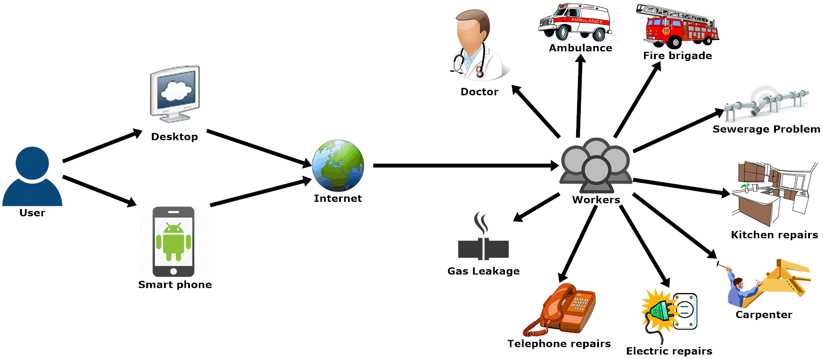

**Usage Scenario**

**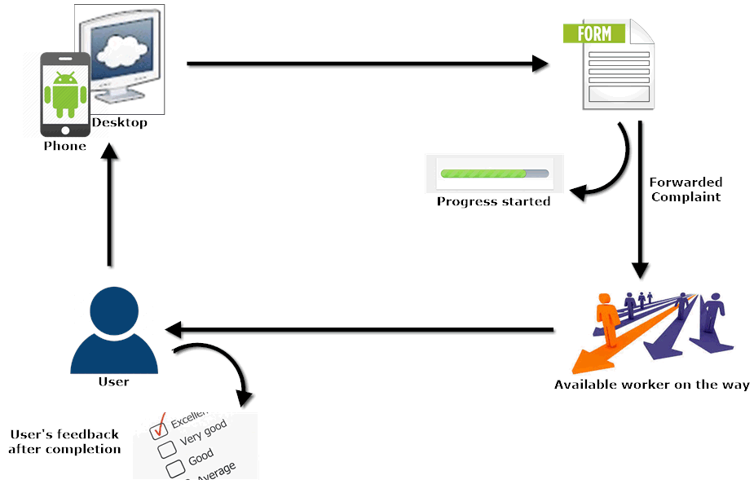**

**UML Diagram (Web)**

****

## 3.4 Development

* Web based work are developed with use of HTML, CSS, PHP and are connected to MySQL for back end receiver and storage of data.
* Mobile application is developed on android studio using Java programming language.
* Rest API endpoints were tested using Postman and Insomnia tools.

# 4.0 Project Planning

## 4.1 Gantt Chart

|  |  |  |  |
| --- | --- | --- | --- |
| Task Name | Duration | Start | Finish |
| **FYP First Evaluation** | **150 days** | **Tue 8/1/17** | **Wed 1/31/18** |
| **Requirement Analysis** | **40 days** | **Tue 8/1/17** | **Tue 10/10/17** |
| Elicitation of Requirement |  | Tue 8/1/17 | Tue 10/10/17 |
| Analysis of Requirement |  | Tue 8/1/17 | Tue 10/10/17 |
| Requirement Validation |  | Tue 8/1/17 | Tue 10/10/17 |
| **Designing** | **30 days** | **Mon 9/11/17** | **Fri 12/1/17** |
| Web Application Design |  | Wed 9/27/17 | Sun 11/19/17 |
| **Implementation** | **40 days** | **Wed 11/1/17** | **Tue 12/26/17** |
| Web Development |  | Wed 11/1/17 | Tue 12/26/17 |
| **Testing** | **50 days** | **Mon 9/11/17** | **Wed 1/31/18** |
| Black Box Testing |  | Wed 11/1/17 | Wed 1/31/18 |
| White Box Testing |  | Wed 9/27/17 | Wed 1/31/18 |

## 4.2 Timeline

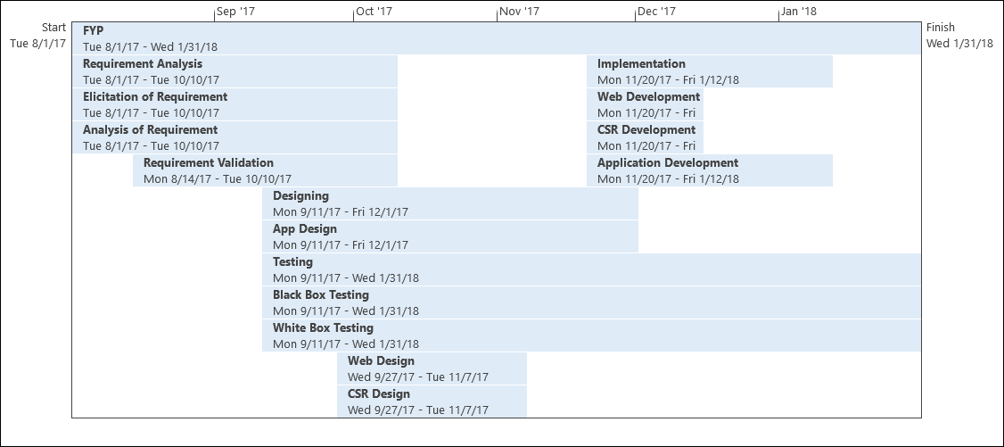

## 4.3 Evidences of Progress

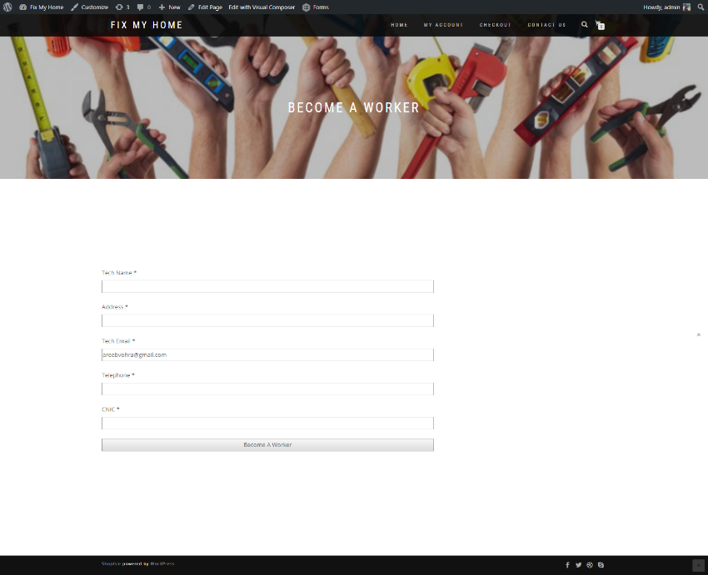

Figure 1 Become a worker

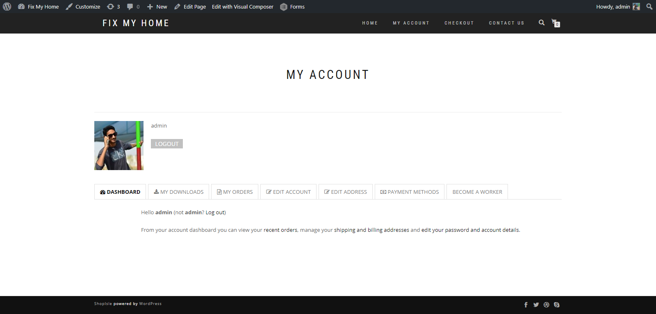

Figure 2 My Account Details

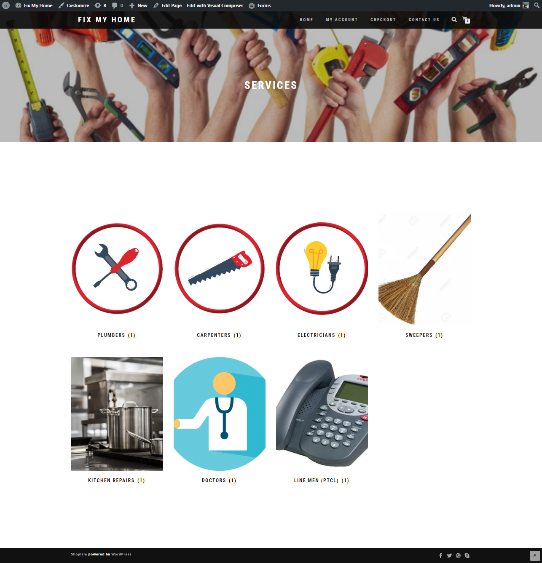

Figure 3 Available Products

# 

# 

# User App Screenshots

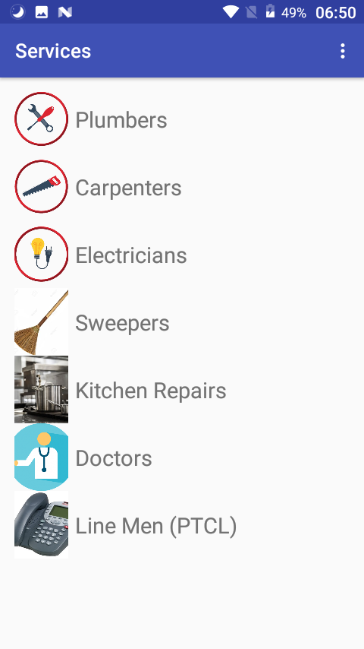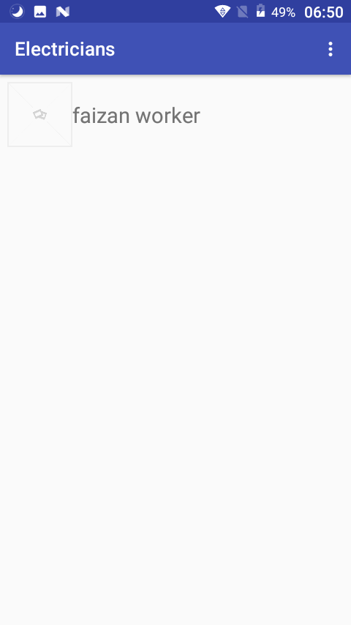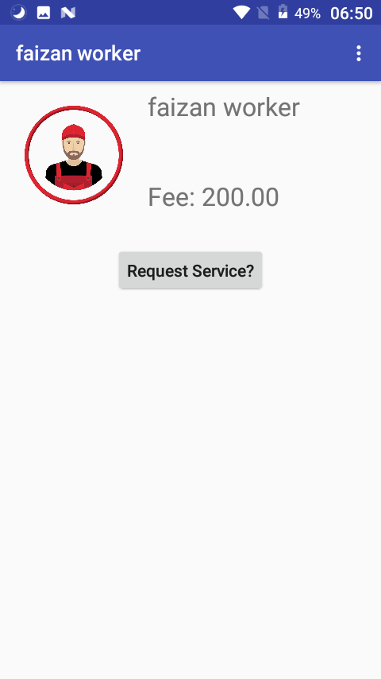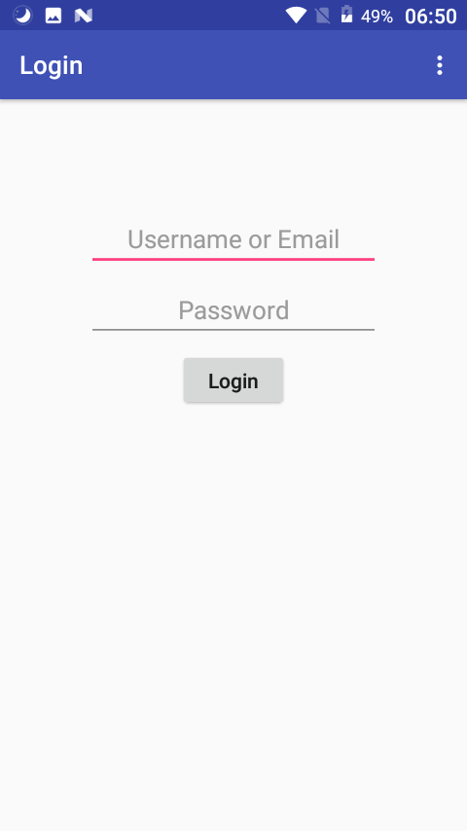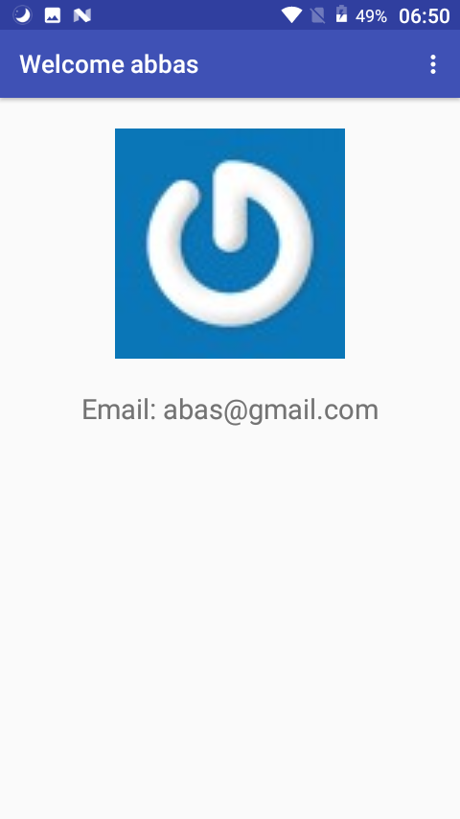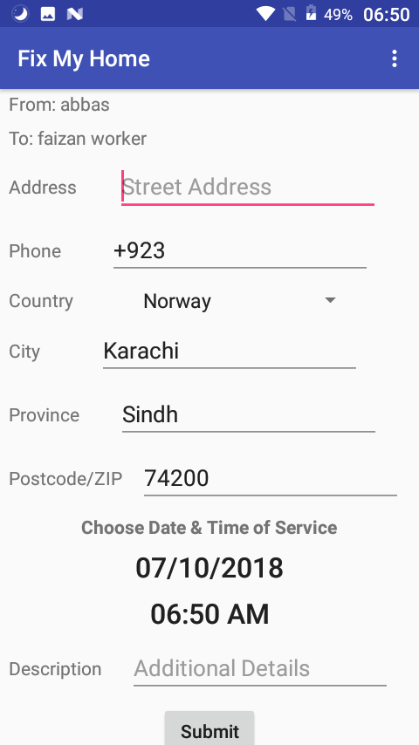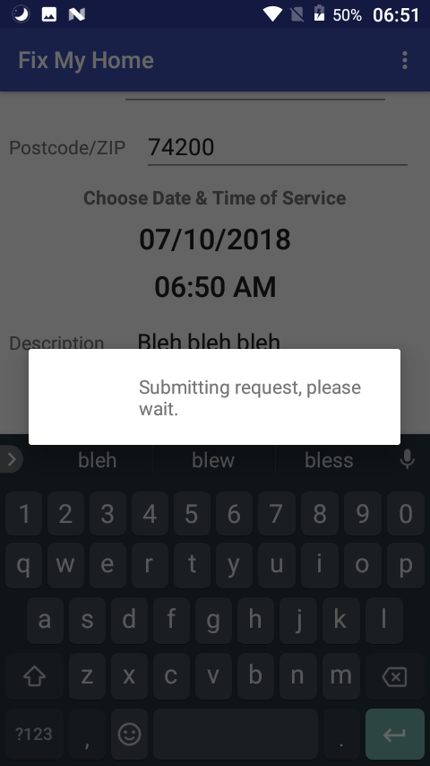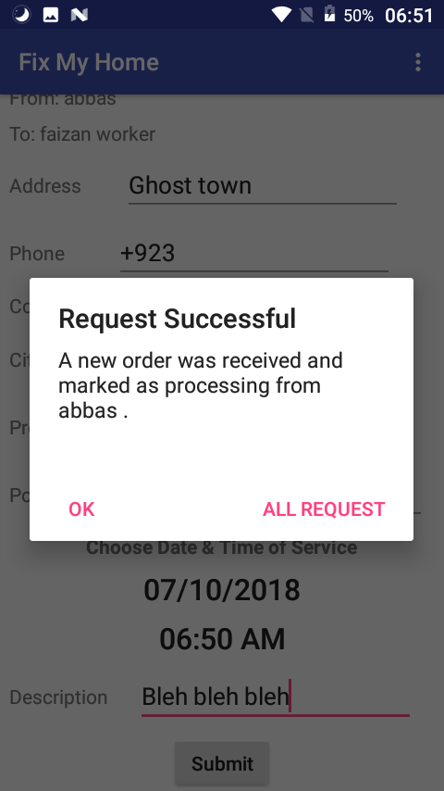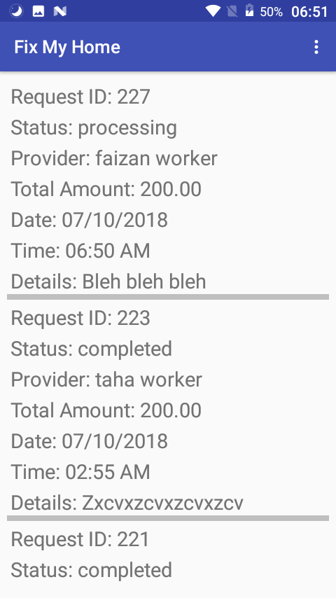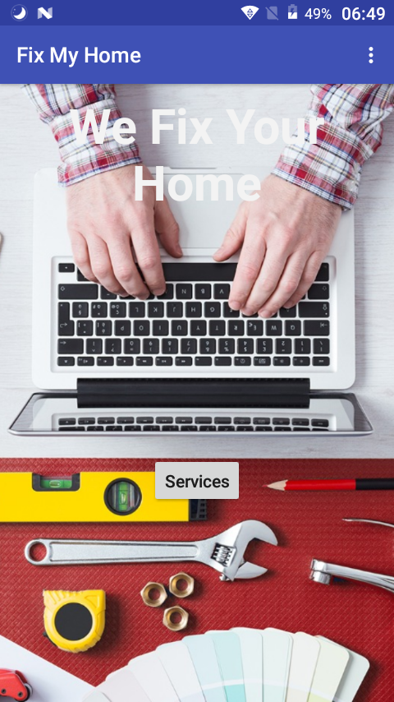

# Worker App Screenshots

## C:\Users\Abdul\Desktop\screenshots\Screenshot_20180710-065159.png C:\Users\Abdul\Desktop\screenshots\Screenshot_20180710-065242.png

## C:\Users\Abdul\Desktop\screenshots\Screenshot_20180710-065247.png C:\Users\Abdul\Desktop\screenshots\Screenshot_20180710-065251.png C:\Users\Abdul\Desktop\screenshots\Screenshot_20180710-065255.png C:\Users\Abdul\Desktop\screenshots\Screenshot_20180710-065156.png

## 4.4 Milestones

***1st Evaluation***  
In progress (First) evaluation, running website (admin & user panel) and their design documents including ERD, Layouts were planned to be submitted.

***Final Report (2nd Evaluation)***  
In final (2nd) evaluation, fully functional website and android application along with technical documents’ soft copies are planned to be submitted.

# 5.0 Project Requirements

## 5.1 Software Tools Requirements

* Android Studio
* Word-Press
* Insomnia
* Postman
* Dream-Viewer
* VS Code
* MySQL
* Android Emulators

## 5.2 Hardware Requirements

* Android Phone *– for mobile application testing.*
* Desktop/Laptop Quad Core Processing Unit *– for Web interface development*
* Internet (3G/4G) Device *– for testing the connection between mediums and research work.*

# 6.0 Budget

## 6.1 Budgeting Cost of Each Item

* Android Mobile [Approx. 15,000 PKR]
* Desktop Quad Core Processing Unit [~10,000-15,000 PKR]
* Internet (3G/4G) device [~4000 PKR]

## 6.2 Total Budgeted Cost

Total budget cost will be Approximately 31,500 PKR.

# 7.0 Project Deliverables

* Proposal Report.
* Requirements Analysis documentation.
* Design Documents (ER-Diagram, design etc.)
* Running Web App.
* Running Android App.
* Software code in CD.

# 8.0 References

1. Gavhane, S., et al., *Study of Implementation of Society Management System.* International Journal of Computer Applications, 2015. **132**(1): p. 34-36.

2. Kumar, S., *Ubiquitous smart home system using android application.* arXiv preprint arXiv:1402.2114, 2014.

3. Vatharkar, R., et al., *IMPLEMENTATION OF SOCIETY MANAGEMENT SYSTEM: SOCIETALES.*

4. Kumbhar, M.D.M.R.M. and A. Dilip, *UBIQUITOUS HOME CONTROL AND MONITORING SYSTEM USING INTERNET OF THINGS.* 2016.

5. Joo, Y.-D., *Implementation of Facility Maintenance Management System using Smart Phones.* The Journal of The Institute of Internet, Broadcasting and Communication, 2013. **13**(1): p. 191-197.